**Exercise 1: Configuring a Basic Spring Application**

//XML file

<?xml version="1.0" encoding="UTF-8"?>

<beans xmlns="http://www.springframework.org/schema/beans"

       xmlns:xsi="http://www.w3.org/2001/XMLSchema-instance"

       xsi:schemaLocation="http://www.springframework.org/schema/beans

       http://www.springframework.org/schema/beans/spring-beans-4.0.xsd">

    <bean id="bookRepository" class="com.library.repository.BookRepository" ></bean>

    <bean id="bookService" class="com.library.service.BookService">

    </bean>

</beans>

package com.library.service;

public class BookService {

public void getBookData() {

System.out.println("In bookService");

}

}

package com.library.repository;

public class BookRepository {

public void fetchBookData() {

System.out.println("in Book Repository");

}

}

package io.spring.LibraryManagement;

import org.springframework.context.ApplicationContext;

import org.springframework.context.support.ClassPathXmlApplicationContext;

import com.library.service.BookService;

import com.library.repository.BookRepository;

public class App

{

    public static void main( String[] args )

    {

     ApplicationContext context = new ClassPathXmlApplicationContext("applicationContext.xml");

         BookService bookService = (BookService)context.getBean("bookService");

         bookService.getBookData();

         BookRepository bookRep = (BookRepository)context.getBean("bookRepository");

         bookRep.fetchBookData();

    }

}

**OUTPUT**:

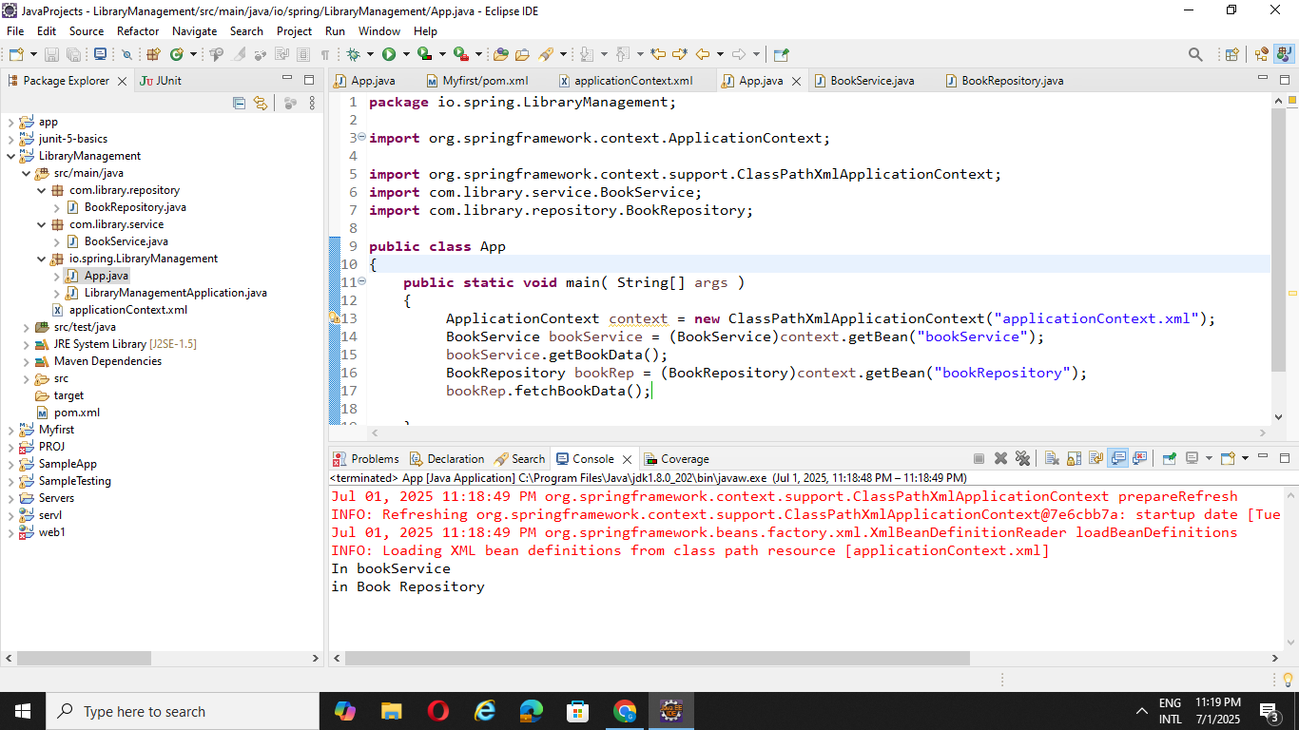

**Exercise 2: Implementing Dependency Injection**

//XML file

<?xml version="1.0" encoding="UTF-8"?>

<beans xmlns="http://www.springframework.org/schema/beans"

       xmlns:xsi="http://www.w3.org/2001/XMLSchema-instance"

       xsi:schemaLocation="http://www.springframework.org/schema/beans

       http://www.springframework.org/schema/beans/spring-beans-4.0.xsd">

    <bean id="bookRepository" class="com.library.repository.BookRepository" ></bean>

    <bean id="bookService" class="com.library.service.BookService">

        <property name="bookRepository" ref="bookRepository"/>

    </bean>

</beans>

package com.library.repository;

public class BookRepository {

public void fetchBookData() {

System.out.println("fetching data from DataBase");

}

}

package com.library.service;

import com.library.repository.*;

public class BookService {

BookRepository bookRepository;

public void setBookRepository(BookRepository bookRepository) {

this.bookRepository = bookRepository;

}

public void getBookData() {

bookRepository.fetchBookData();

System.out.println("Book data's fetched");

}

}

package io.spring.LibraryManagement;

import org.springframework.context.ApplicationContext;

import org.springframework.context.support.ClassPathXmlApplicationContext;

import com.library.service.BookService;

public class LibraryManagementApplication

{

    public static void main( String[] args )

    {

     ApplicationContext context = new ClassPathXmlApplicationContext("applicationContext.xml");

         BookService bookService = (BookService)context.getBean("bookService");

         bookService.getBookData();

    }

}

**OUTPUT:**

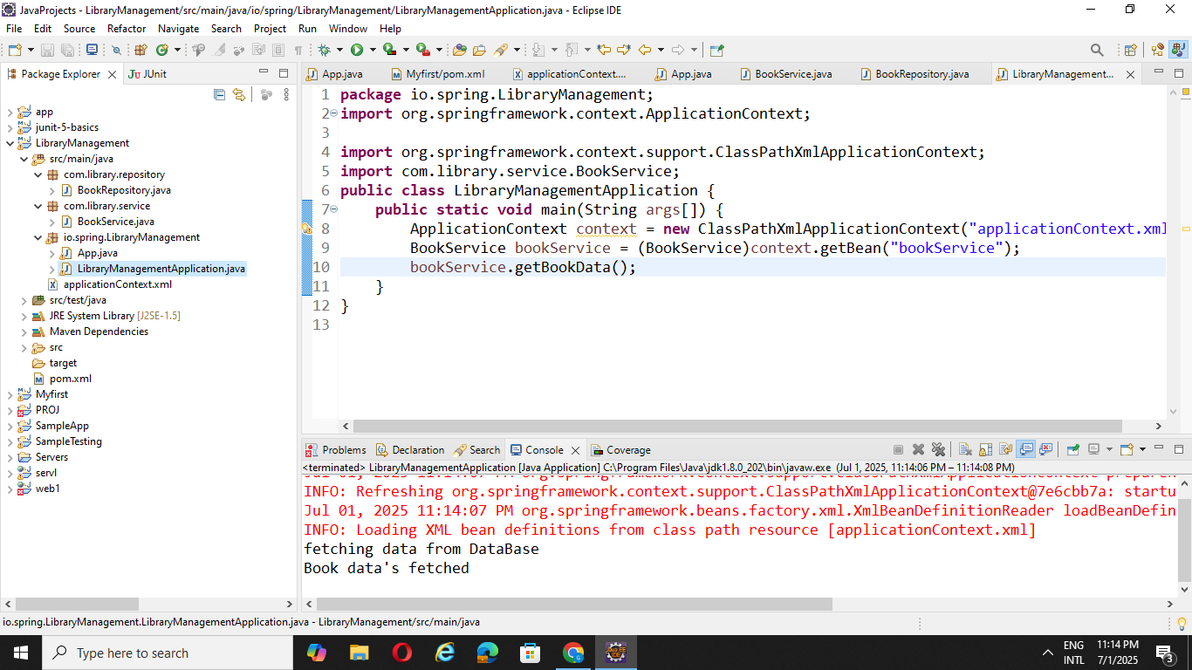

**Exercise 4: Creating and Configuring a Maven Project**

<project xmlns="http://maven.apache.org/POM/4.0.0" xmlns:xsi="http://www.w3.org/2001/XMLSchema-instance"

  xsi:schemaLocation="http://maven.apache.org/POM/4.0.0 http://maven.apache.org/xsd/maven-4.0.0.xsd">

  <modelVersion>4.0.0</modelVersion>

  <groupId>com.gogulan</groupId>

  <artifactId>LibraryManagement_1</artifactId>

  <version>0.0.1-SNAPSHOT</version>

  <packaging>jar</packaging>

  <name>LibraryManagement_1</name>

  <url>http://maven.apache.org</url>

  <properties>

    <project.build.sourceEncoding>UTF-8</project.build.sourceEncoding>

  </properties>

  <dependencies>

    <dependency>

      <groupId>junit</groupId>

      <artifactId>junit</artifactId>

      <version>3.8.1</version>

      <scope>test</scope>

    </dependency>

    <dependency>

        <groupId>org.springframework</groupId>

        <artifactId>spring-context</artifactId>

        <version>5.3.27</version>

    </dependency>

    <dependency>

        <groupId>org.springframework</groupId>

        <artifactId>spring-aop</artifactId>

        <version>5.3.27</version>

    </dependency>

    <dependency>

        <groupId>org.springframework</groupId>

        <artifactId>spring-webmvc</artifactId>

        <version>5.3.27</version>

    </dependency>

  </dependencies>

  <build>

    <plugins>

        <plugin>

            <groupId>org.apache.maven.plugins</groupId>

            <artifactId>maven-compiler-plugin</artifactId>

            <version>3.10.1</version>

            <configuration>

                <source>1.8</source>

                <target>1.8</target>

            </configuration>

        </plugin>

    </plugins>

</build>

</project>

**OUTPUT:**

